**Using a pottery wheel**

Intended users: Teenagers and Adults

Intended System Specifications:

* Touchscreen application
* Icons
* Interactable representation of Pottery Wheel
* Help bubbles
* Guide through using Pottery Wheel using interactable representation

Touchscreen input using fingertips or stylus.

Areas touched by fingertips or stylus light up to enforce user involvement.

Voice recognition is also involved and allows the user to navigate the system using voice and the system repeats the input back to the user.

Visual keyboards also appear when need and show the usual qwerty keyboard to allow typing.

Output Devices include the visual screen output, audio output including music and voice.

The screen uses text, logos, video, animations and visual representations.

I will use large and to the point font and small amounts of text.

The colour scheme will be simple and constant unless an error occurs or help is need in which case vibrant contrasting colours will be used.

I will use a centred layout with all text and picture etc. centred. Virtual representations when used will cover the entire screen for a feeling of fully immersed into the representation.

One of my interface metaphors is the icon for the system which is a Pottery Wheel being used to represent what the user will eventually be capable of doing after using the system.



One of my Direct manipulations is the visual representation of a Pottery Wheel of which it represents a real life Pottery Wheel and how it works. This makes it much easier for the user to learn and apply what they have learned using my UI to using a real Pottery Wheel.

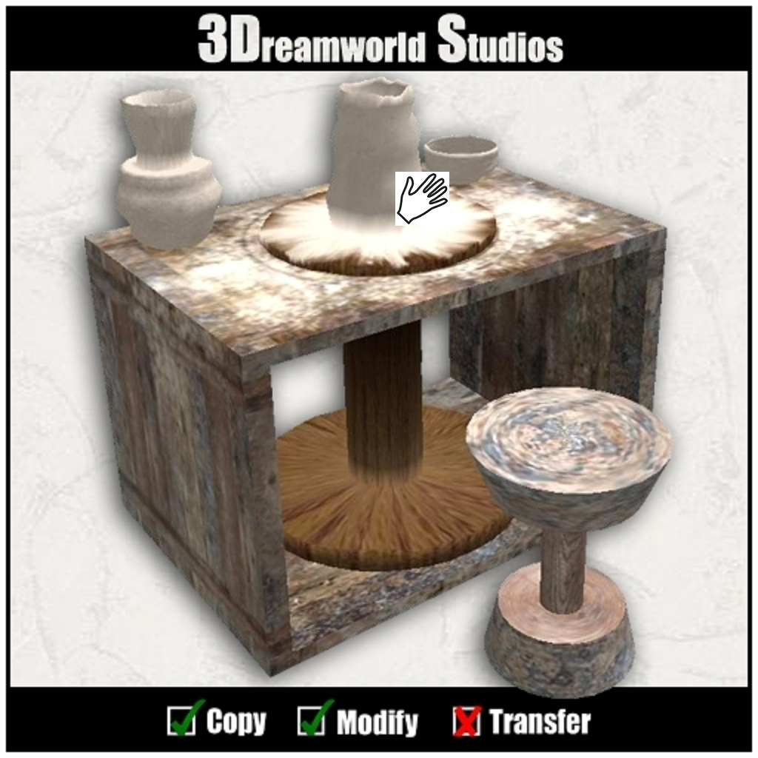

**Command, Menu and Dialog design**

There could be a toolbar which presents the user with different cutting tools and adding clay etc. while making there pottery to represent things they may use/do while doing pottery in real life. This builds a user model (UM) for the real thing.

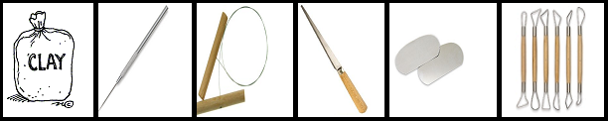

The system will also contain tips and descriptions when the user presses a question mark button and it will also guide them through each step they are presented with using a tutorial system.

